 | AEROLinkers | 

A Detailed Design REPORT

Submitted by

Mr. S. Nithilan, IV-ECE
Ms. S. Monisa, II-ECE
Mr. T. P. Nishanth, II-ECE

Product 360 Contest
by
VVDN Technologies Private Limited

K.S. RANGASAMY COLLEGE OF TECHNOLOGY
(Autonomous)
TIRUCHENGODE – 637 215
January 2025

Product 360 – Abstract

Team Name | AeroLinkers
College Name | K.S.Rangasamy College of Technology
Participants Name | Mr. S. Nithilan, IV-ECE
 | Ms. S. Monisa, II-ECE
 | Mr. T. P. Nishanth, II-ECE
Mentor Name | Dr.C.Rajasekaran
Document Version | V1.3
Date | 20-01-2026

1. Architecture (Section 1)

Architecture Overview and Justification
The system architecture is designed as a low-power, event-driven wearable platform optimized for intermittent connectivity, continuous sensing, and short duration user interactions. The architecture separates always on ultra-low power functions from high energy, event-based operations to achieve predictable battery life and reduced idle power consumption.
A centralized power management subsystem controls multiple regulated domains, enabling selective power gating of high current peripherals.

Hardware Architecture
The hardware architecture consists of:
- A single ultra-low-power MCU responsible for system control
- A companion Wi-Fi IC activated only during connectivity events
- A Power Management Integrated Circuit with battery charging and regulation
- Dedicated subsystems for display, touch, audio, haptics, and motion sensing
Each hardware block is supplied through controlled power rails and communicates with the MCU using standard digital interfaces.
(Detailed design is covered in Section 2)

Software Architecture
The firmware architecture employs a layered RTOS-based design with clear separation between boot-time execution, system management services, hardware drivers, and application-level logic. System behaviour is governed by event notifications rather than continuous polling, minimizing CPU wake ups. Peripheral power states are dynamically managed within the scheduler context to reduce idle current and avoid unnecessary resource activation.
The system software is designed to interoperate with the ATAB Server for selected cloud-assisted functions such as configuration synchronization, device registration, and event data exchange. ATAB Server APIs are consumed strictly at the application layer, ensuring that core device functionality remains operational in offline conditions.
The integration follows a client-initiated, event-based communication model, where the device establishes connectivity only when required. No continuous background synchronization is implemented. This design minimizes power consumption and aligns with the wearable’s event-driven architecture.
ATAB APIs are accessed over a secure IP channel using standard request–response semantics. The API layer is isolated from hardware drivers and RTOS services to prevent tight coupling and to allow future server-side evolution without impacting low-level firmware.
(Detailed design is covered in Section 3)

Mechanical Architecture
The mechanical architecture is designed for a compact wrist-worn form factor, integrating the PCB, battery, display, and haptic components within a sealed enclosure suitable for daily wearable use.
(Detailed design is covered in Section 4)

2. Hardware Detailed Design (Section 2)

Component Selection Matrix
This section documents all key hardware components selected for the system along with justification.
Table 2.1.1 – MCU Comparison and Selection
Parameter | STM32U375RG (Selected) | nRF5340 | CC3551E | STM32U5
MCU type | Ultra-low-power MCU | Radio-centric SoC | Wi-Fi MCU SoC | Feature MCU
Integrated radio | None | BLE | Wi-Fi | None
Active current @ 64 MHz | ~32 µA/MHz | ~55 µA/MHz | ~48 µA/MHz | ~40 µA/MHz
Deep sleep current | ~1.6 µA | ~2.2 µA | ~2.8 µA | ~1.9 µA
Wake-up latency | <10 ms | ~15 ms | ~18 ms | ~12 ms
Flash | Up to 1 MB | 512 KB–1 MB | 1 MB | 512 KB–2 MB
SRAM | Up to 256 KB | 256 KB | 256 KB | 128–786 KB
Lead time | 6–8 weeks | 10–12 weeks | 12–14 weeks | 8–10 weeks

MCU Justification
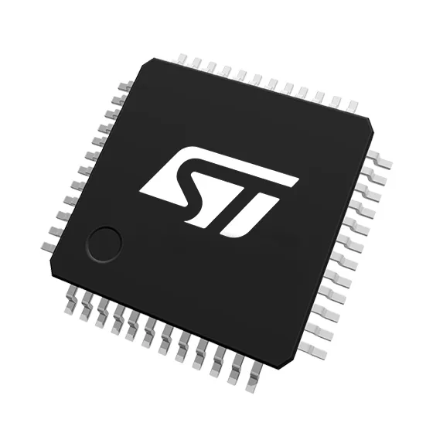
STM32U375RG MCU
STM32U375RG was selected because it delivers the lowest energy per task, the lowest deep sleep current, and no RF related idle leakage, while providing sufficient on-chip memory and certified hardware security. MCUs with integrated radios were rejected due to higher idle power, RF coexistence risk, and increased firmware complexity unsuitable for an event driven wearable.

Table 2.1.2 – Wi-Fi Solution Comparison
Parameter | nRF7002 (Selected) | CC3351 | ESP32-C6
Wi-Fi architecture | Companion IC | Companion IC | SoC
Wi-Fi standard | Wi-Fi 6 (2.4/5 GHz) | Wi-Fi 6 | Wi-Fi 6
Sleep current | <5 µA | ~8 µA | ~20 µA
TX peak current | 262 mA | 400 mA | 480 mA
Energy per TX event | Lowest | 22% | 45%
Interface | SPI | SPI | Internal
10k unit cost | ~$4.8–5.2 | ~$5.6–6.0 | ~$2.8–3.2

Wi-Fi Justification
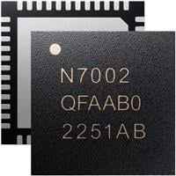
NRF7002 Wi-Fi 6 Companion IC
nRF7002 provides the lowest Wi-Fi energy per event among companion class devices while allowing complete power gating when idle. SoC based Wi-Fi solutions were rejected due to excessive idle current and increased firmware and certification complexity incompatible with smartwatch class power budgets.
Table 2.1.3 – PMIC Comparison
Parameter | nPM1300 (Selected) | MAX20353 | nPM1304
Integrated charger | Yes | Yes | Yes
Buck regulators | 1 programmable | 2 (limited) | 1
Max buck voltage | 3.3 V | 3.85 V | 3.3 V
Wearable optimization | Yes | Medium | Medium
System complexity | Low | Medium | Low
Rail flexibility | Limited | Medium | Limited
Lead time | 6–8 weeks | 8–10 weeks | 6–8 weeks

PMIC Justification
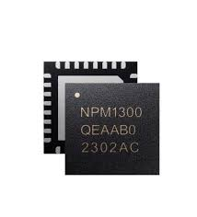
NPM1300 PMIC
nPM1300 was selected for its low complexity wearable class integration, combining charging, regulation, and fuel gauging. Although it offers limited rail flexibility, system power domains are consolidated to avoid unnecessary regulators, reducing BOM and integration risk.
Table 2.1.4 – IMU Comparison
Parameter | LSM6DSOX (Selected) | BMI270 | ICM-42670
Accel LP current | ~12 µA | ~14 µA | ~15 µA
Normal accel current | ~550 µA | ~685 µA | ~720 µA
Embedded intelligence | MLC + FSM | FSM only | None
MCU wake reduction | Highest | Medium | Low
Energy per wake event | Lowest | +25% | +30%
Lead time | 6–8 weeks | 10–12 weeks | 12–14 weeks

IMU Justification
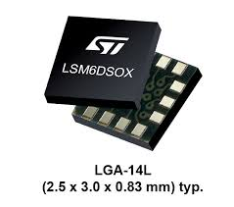
LSM6DSOX 6-Axis IMU
LSM6DSOX was selected due to its embedded motion intelligence, allowing motion decisions without MCU wake ups, resulting in the lowest always-on power consumption and reduced firmware complexity.
Table 2.1.5 – Audio Codec Comparison
Parameter | SGTL5000  (Selected) | MAX98090 | TLV320AIC3204
Idle | ~6 mA | ~9 mA | ~7 mA
Voice playback current | 20–25 mA current | ~30 mA | ~28 mA

Audio Justification
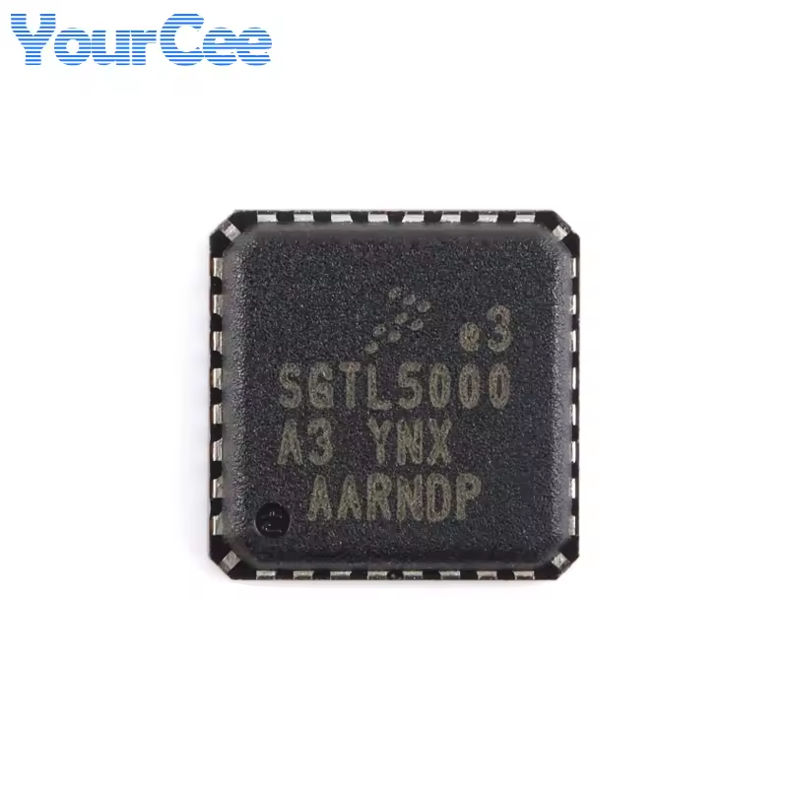
SGTL5000 Stereo Codec Chip
SGTL5000 was selected for voice-prompt-centric usage, offering the lowest energy per alert and minimal analog and firmware complexity. Music-grade codecs were rejected as over-engineered for Gen-1 wearable requirements.
Table 2.1.6 – Haptic Driver Comparison
Parameter | DRV2603 (Selected) | DRV2625 | AW8697
Motor type | LRA | LRA | LRA + ERM
Control | Closed-loop | Closed-loop | Semi-open
Idle current | ~0.5 mA | ~1.0 mA | ~1.5 mA

Haptic Justification
DRV2603 was selected for its voltage independent vibration consistency, lowest idle current, and minimal firmware involvement, making it ideal for accessibility alerts in a wearable device.

Display and Touch Summary
- Display: 1.69″ IPS TFT (280×240)
- Driver: ST7789V2
- Touch: CST816D (single-touch)
This combination provides:
- Predictable power consumption
- Mature driver ecosystem
- Lowest BOM and validation risk for Gen-1
This section describes all digital and analog interfaces.

Interfaces
The system interfaces are designed to support an event-driven, ultra-low-power wearable architecture while maintaining electrical simplicity, signal integrity, and firmware robustness. All interfaces operate at a nominal logic voltage of 2.7 V, eliminating the need for level translation and reducing static and dynamic power consumption.
High-speed interfaces are limited to short-duration, on-demand activity to minimize EMI and energy loss, while low-speed control interfaces remain idle for the majority of system lifetime. Interface selection prioritizes mature protocols, wide ecosystem support, and deterministic timing behavior, ensuring reliable operation in a compact smartwatch-class form factor.
All interfaces are electrically isolated through power-domain control, ensuring that inactive subsystems do not introduce leakage paths or unintended loading. This interface strategy provides a balanced trade-off between power efficiency, signal integrity, and system scalability,
Table 2.2 – Interface Description
Interface | Source | Target | Voltage | Frequency / Data Rate | Purpose
SPI-1 | MCU | IMU | 1.8–3.3 V | Up to 10 MHz | Motion data
SPI-2 | MCU | Display | 1.8–3.3 V | 20–40 MHz | UI rendering
SPI-QSPI | MCU | Wi-Fi IC | 1.8–3.3 V | upto100 MHz | Network data
I²C-1 | MCU | PMIC | 1.8 V | 400 kHz | Power control
I²C-2 | MCU | Touch | 3.3 V | 400 kHz | Touch input
I²S / SAI | MCU | Audio codec | 1.8–3.3 V | Audio clocks | Voice output
GPIO | MCU | Haptic / Button | 3.3 V | — | User feedback

DC & AC AnalysiS

Power Rails – DC Analysis
Power Rail | Source | Nominal Voltage | Min–Max | Max Load Current | Loads Connected
VBAT | Li-Po Battery | 3.7 V | 3.0–4.2 V | 800 mA | PMIC
VSYS | nPM1300 | Unregulated | VBAT − PMIC drop | 1 A | All rails
VOUT-1 | nPM1300 Buck | 2.7 V | 2.62–2.78 V | 200 mA | Display + LED driver
VOUT-2 | nPM1300 Buck | 2.7 V | 2.62–2.78 V | 200 mA | Wi-Fi nRF7002
VDD_LDO | TPS76201 | 2.7 V | ±2% | 100 mA | MCU, IMU, Touch, Audio
LED Rail | CC Driver | Current mode | — | 40 mA | Backlight

MCU GPIO – DC Logic Levels @ 2.7 V
Parameter | Value | Calculation / Basis
VDD | 2.7 V | System rail
VIH (min) | ≥ 1.9 V | 0.7 × VDD
VIL (max) | ≤ 0.8 V | 0.3 × VDD
VOH (min) | ≥ 2.5 V | VDD − 0.2 V
VOL (max) | ≤ 0.2 V | CMOS spec
Max GPIO current | 8 mA | Configured per pin
Internal pull-up | 30–50 kΩ | MCU default
All peripherals selected support 2.7 V logic directly, no level shifting required.

SPI Interface – DC & AC @ 2.7 V
(Display + Wi-Fi)
Parameter | SPI-Display | SPI-Wi-Fi
Logic voltage | 2.7 V | 2.7 V
Clock frequency | 40 MHz | 32 MHz
VIH requirement | ≥1.9 V | ≥1.9 V
Rise/Fall time | <4 ns | <4 ns
Trace impedance | ~50 Ω | ~50 Ω
Series termination | 22–33 Ω | 33 Ω
AC load | Moderate | High (TX bursts)
AC justification at 2.7 V
- Slightly slower edges vs 3.3 V → lower EMI
- SPI margin remains >25% at 40 MHz with controlled routing

I²C Interface – DC & AC @ 2.7 V
(IMU, Touch, Audio control)
Parameter | Value
Bus voltage | 2.7 V
Speed | Fast-mode (400 kHz)
Pull-up resistance | 4.7 kΩ
Pull-up current | ≈ 0.57 mA (2.7 V / 4.7 kΩ)
Max sink capability | >3 mA (all devices)
Rise time (tr) | <300 ns
Fall time (tf) | <300 ns
Bus capacitance | <200 pF
Pull-up current is intentionally kept <1 mA to reduce static loss.

I²S Interface – AC Analysis @ 2.7 V
(MCU ↔ SGTL5000)
Parameter | Value
Logic voltage | 2.7 V
BCLK | 1–3 MHz
LRCLK | 16–48 kHz
Data width | 16 / 24-bit
Clock master | MCU
Edge timing | Data valid on rising edge
Jitter tolerance | <100 ps

AC note: Short trace length and reduced swing at 2.7 V significantly lower digital audio EMI.

Interrupt Lines – DC & AC @ 2.7 V
Source | Type | Voltage | Trigger | Pull-up | Priority
User Button | GPIO | 2.7 V | Falling edge | Internal | Level-1
Touch INT | Open-drain | 2.7 V | Falling edge | 10 kΩ | Level-2
IMU INT | Push-pull | 2.7 V | Rising edge | None | Level-3
Wi-Fi IRQ | Push-pull | 2.7 V | Level | None | Level-3

Analog & Mixed-Signal Stability @ 2.7 V
Subsystem | Sensitivity | Supply | PSRR Needed | Justification
IMU | High | LDO @ 2.7 V | >60 dB | Motion noise immunity
Audio Codec | Very High | LDO @ 2.7 V | >65 dB | Audible noise prevention
Touch | Medium | LDO @ 2.7 V | >50 dB | Gesture reliability
Display Logic | Low | Buck @ 2.7 V | >40 dB | Digital tolerant

EMI & Signal Integrity Summary (2.7 V System)
Aspect | Implementation
Reduced voltage swing | Naturally lower EMI
High-speed SPI | Series damping + short return loops
Audio isolation | Separate LDO + ground island
Wi-Fi bursts | Dedicated buck rail
ESD | TVS on external interfaces

DC & AC Compliance Statement
All digital and analog interfaces operate at 2.7 V nominal, fully within device-specified limits. Signal integrity margins are preserved despite lower swing, while EMI and static power are reduced. This voltage strategy is optimal for an event-driven, Gen-1 wearable and consistent with the locked power architecture.

Power Sequencing

Power-Up Sequence
- Battery or charger applied to PMIC
- PMIC generates VSYS
- Primary buck enabled (MCU + display)
- MCU boots and configures PMIC
- Secondary rails enabled for audio, IMU, haptic
- Wi-Fi rail enabled only when required

Power-Down Sequence
- Reverse order, Wi-Fi disabled first

Power Architecture
- Single-cell Li-Po battery
- PMIC buck generates main system rail
- Secondary LDO provides low-noise rail
- Separate power gating for Wi-Fi and backlight
- Battery voltage and current monitored by PMIC

Power Consumption & Dissipation Calculations
Typical Current Consumption
Operation (Approx. time) | PMIC and LDO | MCU | Wi-Fi | DISPLAY & Back Light (50% PWM) | IMU | AUDIO | HAPTIC (50% PWM) | TOTAL
Booting (5 Sec) | 0.823 | 3 | 180 | 50 | 0.55 | 5 | 30 | 269.37
Data Communication (1 Sec) | 0.823 | 3 | 60 | 0 | 0.55 | 5 | 30 | 99.37
Rest Position | 0.823 | 3 | 60 | 0 | 0.55 | 0 | 0 | 94.37
Wake Position | 0.823 | 3 | 60 | 50 | 0.55 | 0 | 0 | 114.37
Docking | 0.823 | 3 | 60 | 0 | 0.55 | 0 | 0 | 64.37
Vibration (1 Sec) | 0.823 | 3 | 60 | 50 | 0.55 | 0 | 30 | 144.37
(All values in mA)
Estimated runtime: 18–24 hours typical mixed usage.

Reset Scheme
- Power-on reset via PMIC
- Software reset controlled by MCU
- Watchdog reset for fault recovery
- User action button triggers application-level reset

GPIO Mapping
Table 2.8 – GPIO Mapping
MCU Pin | Signal Name | Direction | Connected Subsystem | Interface | Description
PB6 | I2C1_SCL | Bi-dir | PMIC (nPM1300) | I2C-1 | PMIC control, charger & fuel-gauge
PB3 | I2C1_SDA | Bi-dir | PMIC (nPM1300) | I2C-1 | PMIC control, charger & fuel-gauge
PB7 | PMIC_SHPHLD | Output | PMIC | GPIO | Ship-hold / system power latch
PC9 | USER_BTN | Input | User Button | GPIO / EXTI | User action interrupt (internal pull-up)
PB0 | SPI1_CS | Output | IMU (LSM6DSOX) | SPI-1 | IMU chip select
PA7 | SPI1_SCK | Output | IMU (LSM6DSOX) | SPI-1 | IMU SPI clock
PA6 | SPI1_MISO | Input | IMU (LSM6DSOX) | SPI-1 | IMU data to MCU
PB1 | IMU_INT1 | Input | IMU (LSM6DSOX) | GPIO / EXTI | Motion / wake interrupt
PB2 | IMU_INT2 | Input | IMU (LSM6DSOX) | GPIO / EXTI | Secondary motion interrupt
PC7 | HAPTIC_EN | Output | Haptic Driver (DRV2603) | GPIO | Enables haptic driver
PC8 | HAPTIC_PWM | Output | Haptic Driver (DRV2603) | PWM | Vibration amplitude control
PB10 | WIFI_CLK | Output | Wi-Fi (nRF7002) | QSPI-1 | Clock
PA4 | WIFI_SS | Output | Wi-Fi (nRF7002) | QSPI-1 | Slave select
PC10 | WIFI_D0_MOSI | Output | Wi-Fi (nRF7002) | QSPI-1 | Data 0 / MOSI
PC12 | WIFI_D1_MISO | Input | Wi-Fi (nRF7002) | QSPI-1 | Data 1 / MISO
PD2 | WIFI_D2 | Bi-dir | Wi-Fi (nRF7002) | QSPI-1 | Data line 2
PC6 | WIFI_D3 | Bi-dir | Wi-Fi (nRF7002) | QSPI-1 | Data line 3
PC5 | WIFI_IRQ | Input | Wi-Fi (nRF7002) | GPIO / EXTI | Wi-Fi interrupt
PC0 | I2C3_SCL | Bi-dir | Audio Codec (SGTL5000) | I2C-3 | Codec configuration
PC1 | I2C3_SDA | Bi-dir | Audio Codec (SGTL5000) | I2C-3 | Codec configuration
PA7 | I2S_DOUT | Input | Audio Codec (SGTL5000) | SAI-1 / I2S | Mic data to MCU
PB5 | I2S_DIN | Output | Audio Codec (SGTL5000) | SAI-1 / I2S | Audio data to codec
PA5 | I2S_SCLK | Output | Audio Codec (SGTL5000) | SAI-1 / I2S | Serial clock
PA4 | I2S_LRCLK | Output | Audio Codec (SGTL5000) | SAI-1 / I2S | Frame sync
PC3 | SPI2_DIO | Output | Display (ST7789V2) | SPI-2 | Display data
PA9 | SPI2_SCK | Output | Display (ST7789V2) | SPI-2 | Display clock
PB12 | SPI2_CS | Output | Display (ST7789V2) | SPI-2 | Display chip select
PB13 | TOUCH_I2C_SDA | Bi-dir | Touch (CST816D) | I2C-2 | Touch data
PB14 | TOUCH_I2C_SCL | Bi-dir | Touch (CST816D) | I2C-2 | Touch clock
PC2 | DISP_RST | Output | Display | GPIO | Display reset
PA0 | LED_PWM_BL | Output | Backlight Driver | PWM | LED backlight current control

Interrupt Mapping

Priority Order
- User action button
- Touch interrupt
- IMU motion interrupt
- Wi-Fi interrupt
Interrupts are edge-triggered and handled by RTOS ISR callbacks.

3. Software Detailed DesigN (Section 3)

CPU Selection Matrix
(Condensed comparison table retained here, detailed analysis already validated)
STM32U375RG selected due to:
- Lowest µA/MHz
- No RF leakage
- Adequate memory
- Certified security features

Memory Requirements Analysis & Estimation
This section analyzes the non-volatile and volatile memory requirements of the system firmware and validates that the selected MCU provides sufficient margin for current functionality and future scalability. Memory estimation is based on actual functional blocks, RTOS overhead, and worst-case concurrent execution, rather than optimistic averages.
The system is designed to avoid external memory, reducing power consumption, BOM cost, and integration risk.

MCU Memory Availability (Reference)
Memory Type | Available on MCU
Internal Flash | 512 KB
Internal SRAM | 256 KB
External Memory | Not used

Flash Memory Requirement Analysis
Flash memory is used for bootloader, RTOS kernel, device drivers, application code, configuration tables, and OTA support.
Flash Usage Category | Estimated Size (KB) | Basis
Secure Bootloader | 32 KB | Image validation, fallback logic
Zephyr RTOS Kernel | 60 KB | Scheduler, IPC, power mgmt
HAL & BSP | 45 KB | MCU peripherals
Device Drivers | 85 KB | Display, touch, IMU, audio, haptic, PMIC
Wi-Fi Stack & Driver | 70 KB | SPI-based companion control
Application Logic | 90 KB | UI, alerts, navigation logic
Configuration & Tables | 20 KB | Fonts, UI strings, language
Diagnostics & CLI | 25 KB | SSH-based CLI
Subtotal | 427 KB
Flash Safety Margin (~15%) | 65 KB | Future updates
Total Required | ≈492 KB
Conclusion (Flash):
The 512 KB internal flash provides sufficient capacity with controlled margin. Dual-image OTA is possible but constrained; Gen-1 implementation uses single-image + rollback protection to preserve margin.

RAM Requirement Analysis
RAM usage includes RTOS kernel data, stacks for concurrent threads, heap allocations, DMA buffers, and frame buffers.
a) RTOS & System Overhead
Component | RAM Usage (KB)
Zephyr kernel objects | 12 KB
IPC queues & events | 8 KB
Timer & scheduler data | 6 KB
Subtotal | 26 KB

b) Thread Stack Allocation (Worst-Case)
Thread / Task | Stack Size (KB)
Main application thread | 16 KB
UI / Display task | 20 KB
Wi-Fi control task | 18 KB
Audio playback task | 16 KB
Sensor / IMU task | 12 KB
CLI / Diagnostics task | 14 KB
Idle / system task | 6 KB
Subtotal | 102 KB

c) Dynamic Buffers & DMA
Buffer Type | Size (KB)
Display line/frame buffers | 32 KB
Audio DMA buffers | 16 KB
Wi-Fi SPI buffers | 24 KB
Sensor data buffers | 8 KB
Subtotal | 80 KB

d) Heap & Safety Margin
Category | Size (KB)
Heap allocation | 20 KB
RAM safety margin (~10%) | 20 KB

Total RAM Estimation Summary
Category | RAM (KB)
RTOS & kernel | 26
Thread stacks | 102
Buffers & DMA | 80
Heap | 20
Safety margin | 20
Total Required | 248 KB
Conclusion (RAM):
The estimated RAM usage fits within the 256 KB internal SRAM with tight but acceptable margin. Stack sizes are intentionally conservative to avoid runtime overflow. No external RAM is required.

Memory Optimization Strategy
To maintain margin and reliability:
- Display uses line buffering, not full-frame buffering
- Wi-Fi buffers allocated only during active sessions
- Audio buffers released immediately after playback
- Static allocation preferred over heap where possible
- Stack usage monitored using RTOS watermarking

Memory Sufficiency Conclusion
The selected MCU memory configuration is right-sized for the Gen-1 wearable:
- No excess memory causing leakage
- No external memory integration risk
- Sufficient margin for firmware refinement and feature tuning
This memory strategy aligns with the product goal of low power, low complexity, and high reliability.

IDE, OS & Device Drivers
- IDE: STM32CubeIDE
- RTOS: Zephyr
- Device drivers: Native Zephyr drivers
- CLI access via SSH using WolfSSH

Boot Flow
- Power-on reset
- Secure boot validation
- RTOS initialization
- Peripheral bring-up
- Application start

Key Peripheral Initialization Flow
- Clock configuration
- GPIO setup
- PMIC configuration
- IMU and touch init
- Display init
- Audio and haptic init

List of Applications
- Device information
- Language selection
- Display settings
- Audio & haptic alerts
- Flight / navigation alerts
- Power and diagnostics

ATAB Server API Integration

Purpose of ATAB Server Integration
ATAB Server APIs are used to support non-time-critical, non-safety-critical functions such as:
- Device identification and provisioning
- Retrieval of user- or session-specific data
- Upload of device-generated events (status, alerts)
- Configuration updates
All core wearable functions (navigation cues, alerts, haptics, display, audio) do not depend on continuous ATAB server availability.

Communication Model
Aspect | Description
Communication Type | Client-initiated
Transport | IP-based (over Wi-Fi)
Session Type | Short-lived
Connectivity Mode | Event-triggered
Retry Strategy | Limited retries with timeout
Offline Behavior | Graceful degradation
The device initiates communication with ATAB Server only when:
- User action explicitly requires data
- A scheduled sync window is reached
- Configuration refresh is requested

ATAB API Usage Context
API Category | Device Usage Context
Device Registration | First boot / factory reset
Device Status API | On-demand health reporting
Configuration API | Language, preferences, alerts
Event Upload API | Post-event synchronization
Authentication APIs | Session establishment
No ATAB API is invoked from ISR context or real-time tasks.

Software Layer Placement
Layer | Responsibility
Application Layer | API request formation, response parsing
Middleware | JSON parsing, message validation
Network Stack | TCP/IP, TLS
RTOS / HAL | Scheduling, memory, drivers
ATAB APIs are never accessed directly by device drivers.

3.X.5 Security Considerations
- Secure session establishment prior to API access
- Credentials stored in MCU secure storage
- API access restricted to authenticated sessions
- No sensitive data stored persistently unless required
Security implementation aligns with MCU hardware cryptographic capabilities.

Failure Handling Strategy
Failure Case | Device Behavior
Server unreachable | Local operation continues
API timeout | Retry with backoff
Authentication failure | User notification (if required)
Invalid response | Response discarded, logged
Failure of ATAB APIs does not block user-facing functions.

Command Line Interface
- Access via Wi-Fi
- SSH-based secure CLI
- Used for diagnostics, logs, and configuration

ATAB Diagnostic Commands
ATAB integration is supported by CLI-level diagnostics for development and testing purposes.
Command | Description
atab_status | Check server connectivity
atab_auth | Validate authentication
atab_sync | Trigger manual sync
atab_log | Display last API transaction
These commands are disabled or restricted in production builds.

4. Mechanical Detailed Design (Section 4)

4.1 Exploded View of Concept Design
- Front glass + display
- Touch sensor
- Main PCB
- Battery
- Haptic motor
- Enclosure and strap
Assembly sequence ensures minimal rework and safe battery handling.
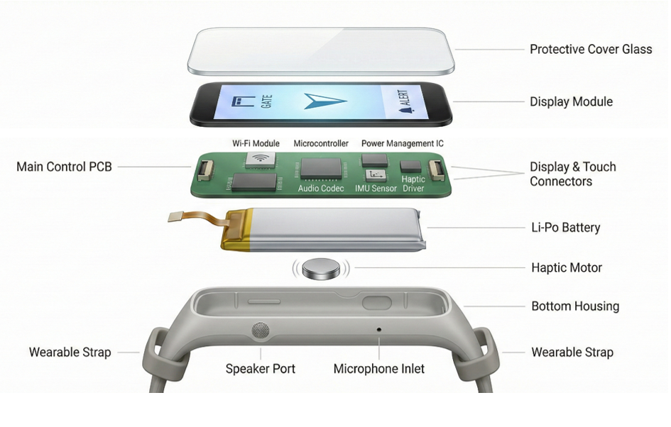
Fig 4.1 Exploded view
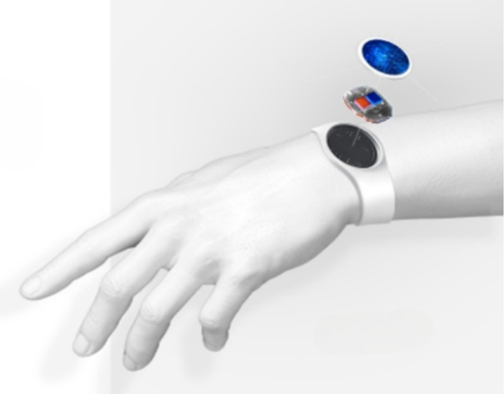
Fig 4.2 Exploded view in Hand Wrist

